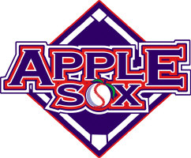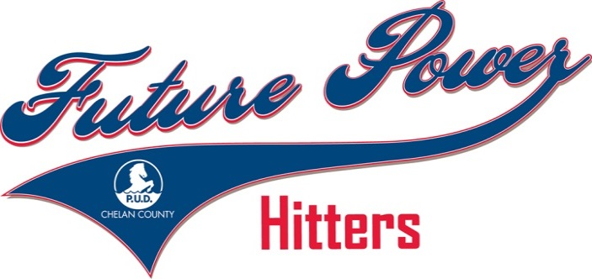

Wenatchee AppleSox
Bat Kids Registration Form

Here’s your opportunity to be a part of the AppleSox Baseball Club’s exciting “Future Power Hitters” bat kids program, sponsored by the Chelan County PUD. Each participant will receive an official Future Power Hitter Bat Kid jersey to keep!

Choose your series:
____ June 3, 4, 5
____ June 10, 11, 12
____ June 14, 15, 16
____ June 17, 18, 19
____ June 27, 28, 29
____ July 3, 4, 5 (fireworks shown on the third)
____ July 9, 10, 11
____ July 12, 13, 14
____ July 20, 21, 22
____July 29, 30, 31
____ August 5, 6, 7
____ Possible Division Series, August 9, 10, 11
____ Possible Championship Series, August 13, 15, 16

To apply, you must:
• Be at least 10 years old
• Have a good understanding of the game of baseball
• Be available for at least one complete series (up to 4 games)

Child Name _____________________________________________ Age ________
Parent/Guardian Name _________________________________________________
Address _____________________________________________________________
City, State, Zip ________________________________________________________
Phone _______________________________________________________________
Emergency Contact ____________________________________________________
Emergency Phone _____________________________________________________
E-mail Address ________________________________________________________
Future Power Hitter Bat Kids will be notified by the AppleSox if they have been chosen for a series.
Mail to 610 N. Mission St., #204, Wenatchee, WA. 98801. Or email to Ken Osborne at ken@applesox.com

Applicants must sign the consent form on reverse side!
RELEASE & WAIVER OF LIABILITY, ASSUMPTION
OF RISK, INDEMNITY AND PARENTAL CONSENT AGREEMENT

PLEASE READ BEFORE SIGNING!

In consideration of being allowed to participate in any way in Wenatchee Baseball Club, L.L.C. (the
“Releasee”) athletic sports program, related events and activities (the “Baseball Activities”), the undersigned participant and/or legal guardian (the “Parent”), for themselves, their heirs, successors and assigns:

1. ACKNOWLEDGE, agree and represent the nature of Baseball Activities involves risk and dangers of serious bodily injury, including permanent disability, paralysis and death. These risks and dangers may be caused not only by the inherent nature of Baseball Activities, but also by the Participant’s actions or inaction, the action or inaction of others, and other conditions in which the Baseball Activity takes place, or the negligence of the Releasee. There may be other risks and social and economic losses which may arise from the Baseball Activities which are either not known or not readily forseeable at this time, but which are intended to be addressed by this Agreement;

2. ASSUME ALL SUCH RISKS, both known and unknown. EVEN IF ARISING FROM THE NEGLIGENCE OF THE RELEASEES or others, and assumes full responsibility for the Participant’s participation in the Baseball Activities;

3. AGREE to comply with the stated and customary items and conditions for participation. If, however, I observe any unusual significant hazard or condition during Baseball Activities, the Participant will remove themselves from participation and will immediately bring such hazard or condition to the attention of the nearest official of the Releasee immediately, and;

4. RELEASE, INDEMNIFY AND HOLD HARMLESS the officers, official agents, and/or employees, other participants, sponsoring agencies, sponsors, advertisers, and if applicable, owners and lessons on the premesis used to conduct the Baseball Activities (also “Releasee), WITH RESPECT TO ANY AND ALL INJURY, DISABILITY, DEATH, or loss or damage to person or property arising from the Baseball Activity. WHETHER ARISING FROM THE NEGLIGENCE OF THE RELEASEES OR OTHERWISE;

5. As the Participant’s Parent, I specify consent to the Participant’s participation in the Baseball Activities and confirm and assume the foregoing. I further represent the Participant is qualified, in good health and in proper physical condition to participate in the Baseball Activities and RELEASE, DISCHARGE, COVENANT NOT TO SUE, INDEMNIFY AND HOLD each Releasee HARMLESS from all liability, claims, demands, losses, or damages on the account of the Parent and the Participant, and their respective heirs, successors and assigns which may arise during the Baseball Activity, and whether caused or alleged to be caused in whole or in part by the negligence of the Releasee or otherwise, and further agree that if, despite this Release, the Parent, the Participant, or anyone on behalf of the Participant, makes a claim against and Releasee, the Parent will INDEMNIFY and HOLD each Releasee HARMLESS from any litigation expenses, attorney fees, loss liability, damage, or cost which may be incurred as the result of any such claim.

I HAVE READ THIS RELEASE AND WAIVER OF LIABILITY, ASSUMPTION OF RISK, AND INDEMNITY
AGREEMENT, FULLY UNDERSTANDING ITS TERMS, UNDERSTAND THAT I HAVE GIVEN UP
SUBSTANTIAL RIGHTS BY SIGNING IT, AND SIGN IT FREELY AND VOLUNTARILY WITHOUT INDUCEMENT, IN CONSIDERATION OF THE PARTICIPATION OF THE BASEBALL ACTIVITIES BY THE PARTICIPANT.

Participant’s Name ________________________________________________________________

Parent/Guardian’s Signature __________________________________ Date Signed ____________

